ASSIGNMENT – 9.3
AI ASSISTED CODING
NAME : G.HARSHAVARDHAN
HALLTICKECT NO : 2403A52313
BATCH NUMBER : 01
COURSE CODE : 24CS002PC215
PROGRAM NAME : B.TECH
YEAR/SEM : 2ND AND 3RD

Task Description#1 Basic Docstring Generation
- Write python function to return sum of even and odd numbers in the given list.
- Incorporate manual docstring in code with Google Style
- Use an AI-assisted tool (e.g., Copilot, Cursor AI) to generate a docstring describing the function.
- Compare the AI-generated docstring with your manually written one.

Expected Outcome#1: Students understand how AI can produce function-level documentation.
PROMT:
"Write a Python function sum_even_odd(numbers) that takes a list of integers as input and returns a tuple containing the sum of even numbers and the sum of odd numbers in the list.

CODE:
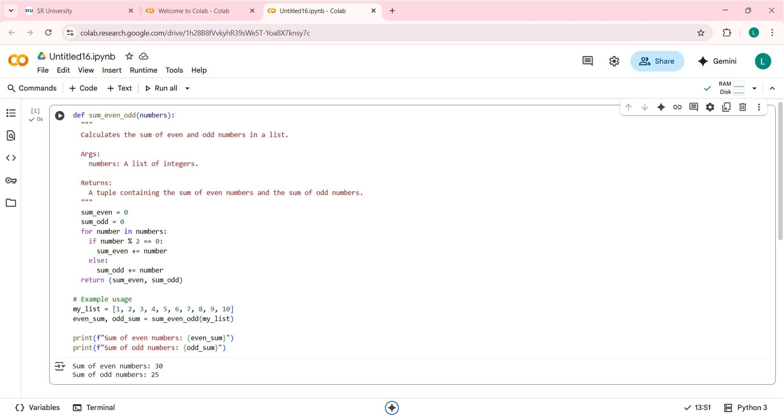
OUTPUT:
Sum of even numbers: 30
Sum of odd numbers: 25
OBSERVATION:
The code defines a function sum_even_odd that successfully separates and sums the even and odd numbers in the provided list my_list.
- The list my_list contains integers from 1 to 10.
- The even numbers in the list are 2, 4, 6, 8, and 10. Their sum is 30.
- The odd numbers in the list are 1, 3, 5, 7, and 9. Their sum is 25.
- The code correctly calculates and prints these sums as shown in the output: "Sum of even numbers: 30" and "Sum of odd numbers: 25".
- The function returns a tuple (30, 25) which is then unpacked into the even_sum and odd_sum variables.

Task Description#2 Automatic Inline Comments
- Write python program for sru_student class with attributes like name, roll no., hostel_status and fee_update method and display_details method.
- Write comments manually for each line/code block
- Ask an AI tool to add inline comments explaining each line/step.
- Compare the AI-generated comments with your manually written one.
Expected Output#2: Students critically analyze AI-generated code comments.
PROMT:
Create a Python class sru_student with the following attributes: name, roll_no, and hostel_status. Implement methods fee_update and display_details.

CODE:
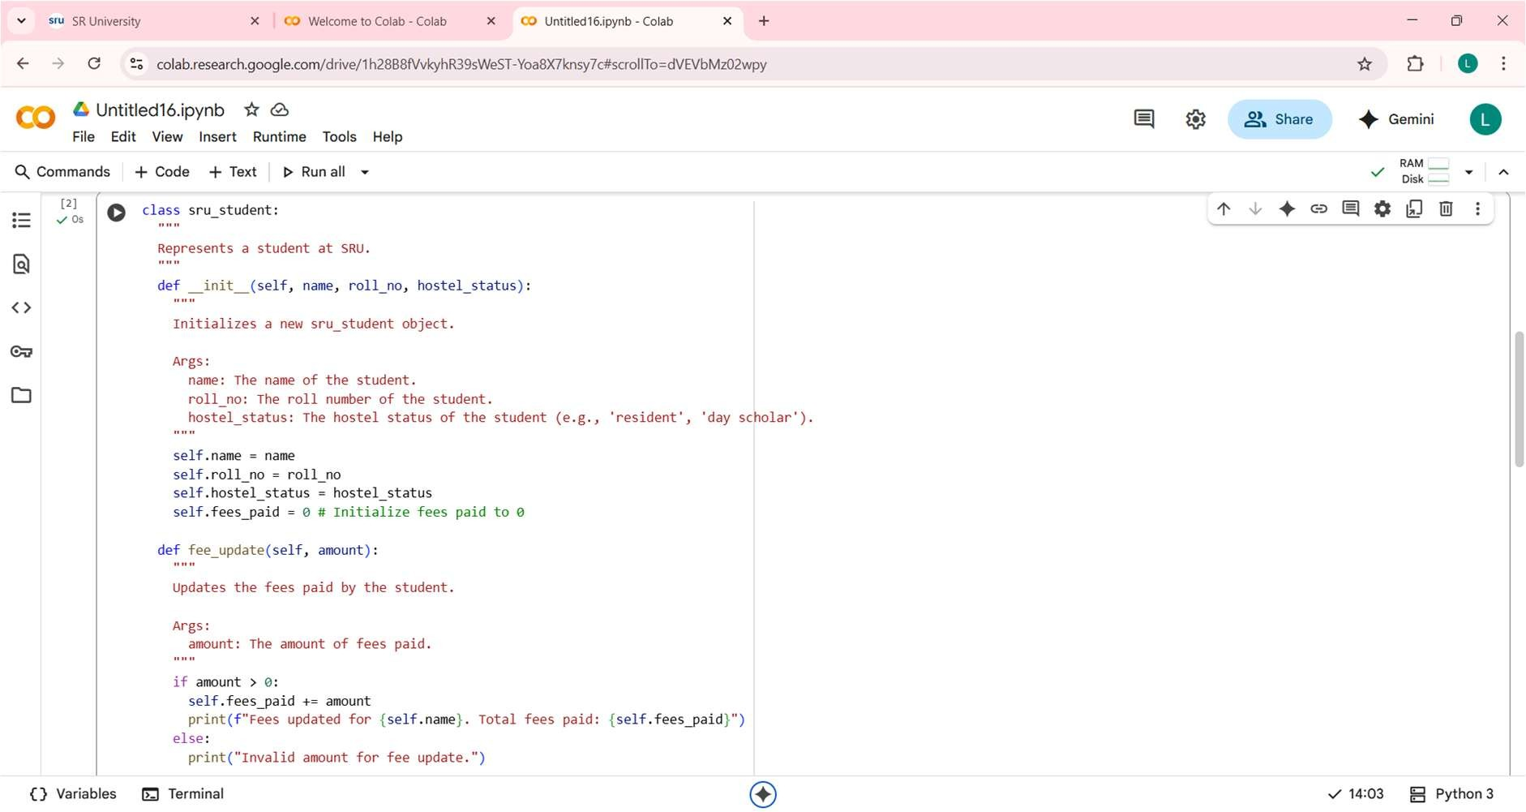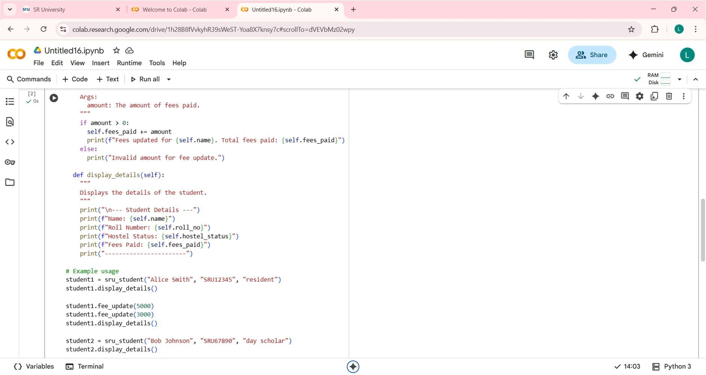
OUTPUT:
--- Student Details ---
Name: Alice Smith
Roll Number: SRU12345
Hostel Status: resident
Fees Paid: 0
-----------------------
Fees updated for Alice Smith. Total fees paid: 5000
Fees updated for Alice Smith. Total fees paid: 8000

--- Student Details ---
Name: Alice Smith
Roll Number: SRU12345
Hostel Status: resident
Fees Paid: 8000
-----------------------

--- Student Details ---
Name: Bob Johnson
Roll Number: SRU67890
Hostel Status: day scholar
Fees Paid: 0
-----------------------
OBSERVATION:
- The code successfully defines a Python class sru_student to represent students with specific attributes and methods.
- The __init__ method correctly initializes the name, roll_no, hostel_status, and fees_paid attributes when a new student object is created. The fees_paid is correctly set to 0 initially.
- The fee_update method allows for updating the fees_paid attribute, and the example shows that consecutive updates (5000 and 3000) correctly accumulate the total fees paid (resulting in 8000).
- The display_details method accurately prints the current details of the student object it is called on.
- Creating multiple instances of the class ( student1 and student2) demonstrates that each object maintains its own unique set of attribute values.
- The output clearly shows the initial state of student1, the fee updates, the updated state of student1, and the initial state of student2, confirming that the methods work as intended.

Task Description#3
- Write a Python script with 3–4 functions (e.g., calculator: add, subtract, multiply, divide).
- Incorporate manual docstring in code with NumPy Style
- Use AI assistance to generate a module-level docstring + individual function docstrings.
- Compare the AI-generated docstring with your manually written one.
Expected Output#3: Students learn structured documentation for multifunction scripts
PROMT:
"Write a Python script with 4 calculator functions (add, subtract, multiply, divide). Include NumPy-style docstrings. First, generate AI-written modulelevel and function docstrings. Then, provide a manually written version for comparison and summarize the di erences."

CODE:
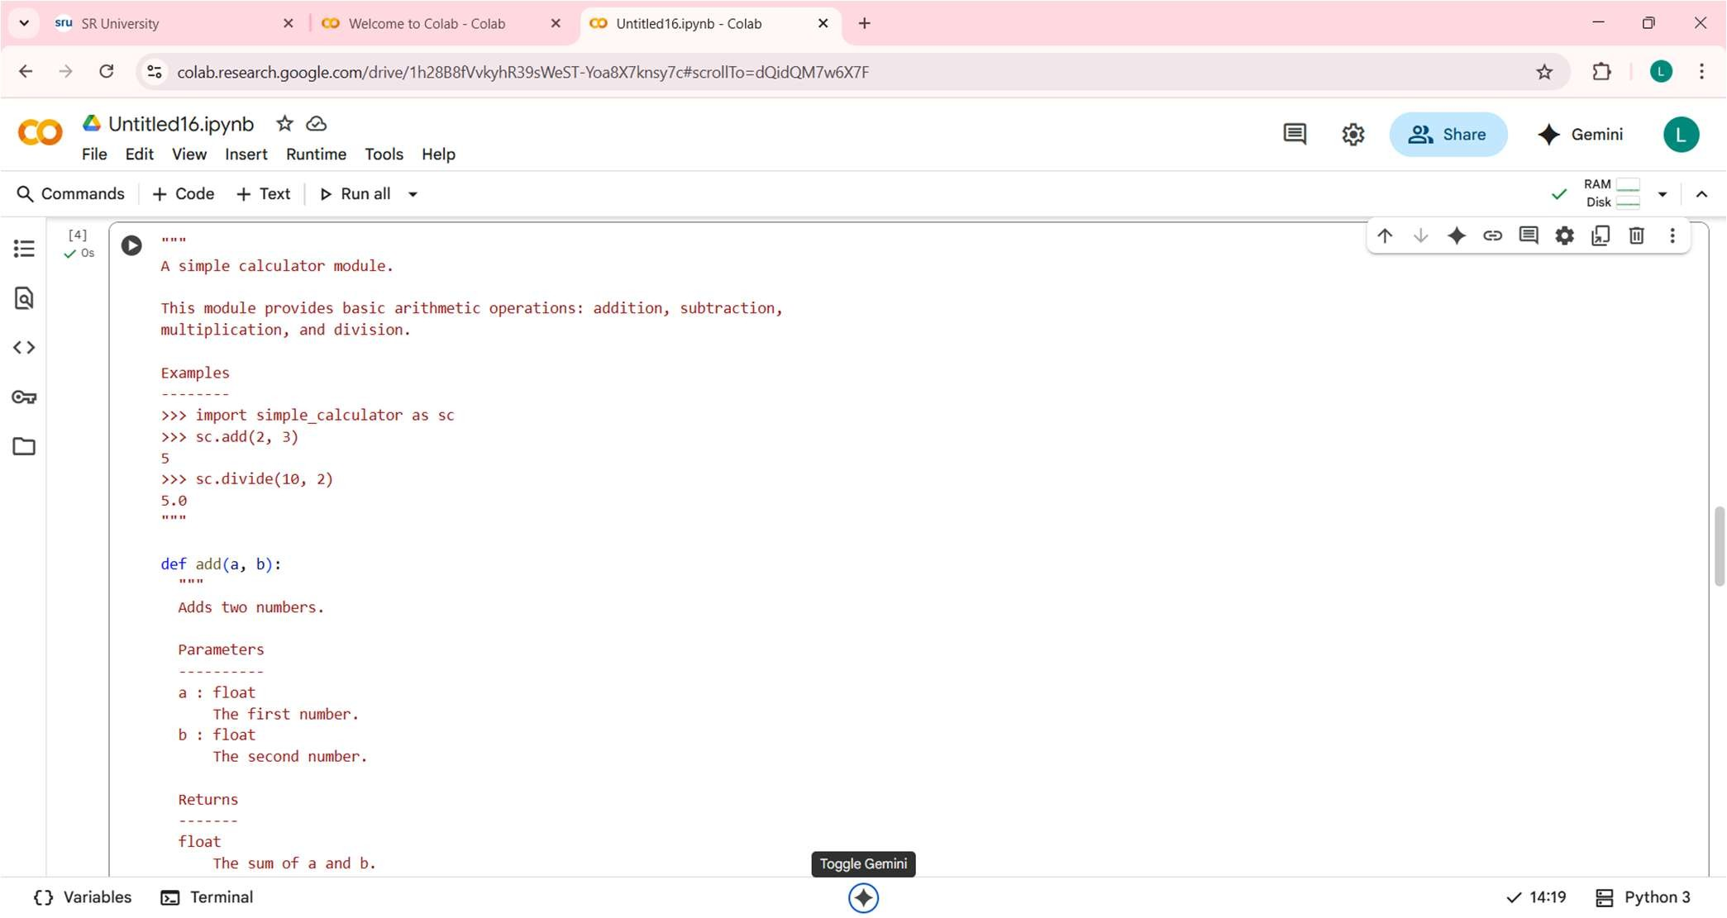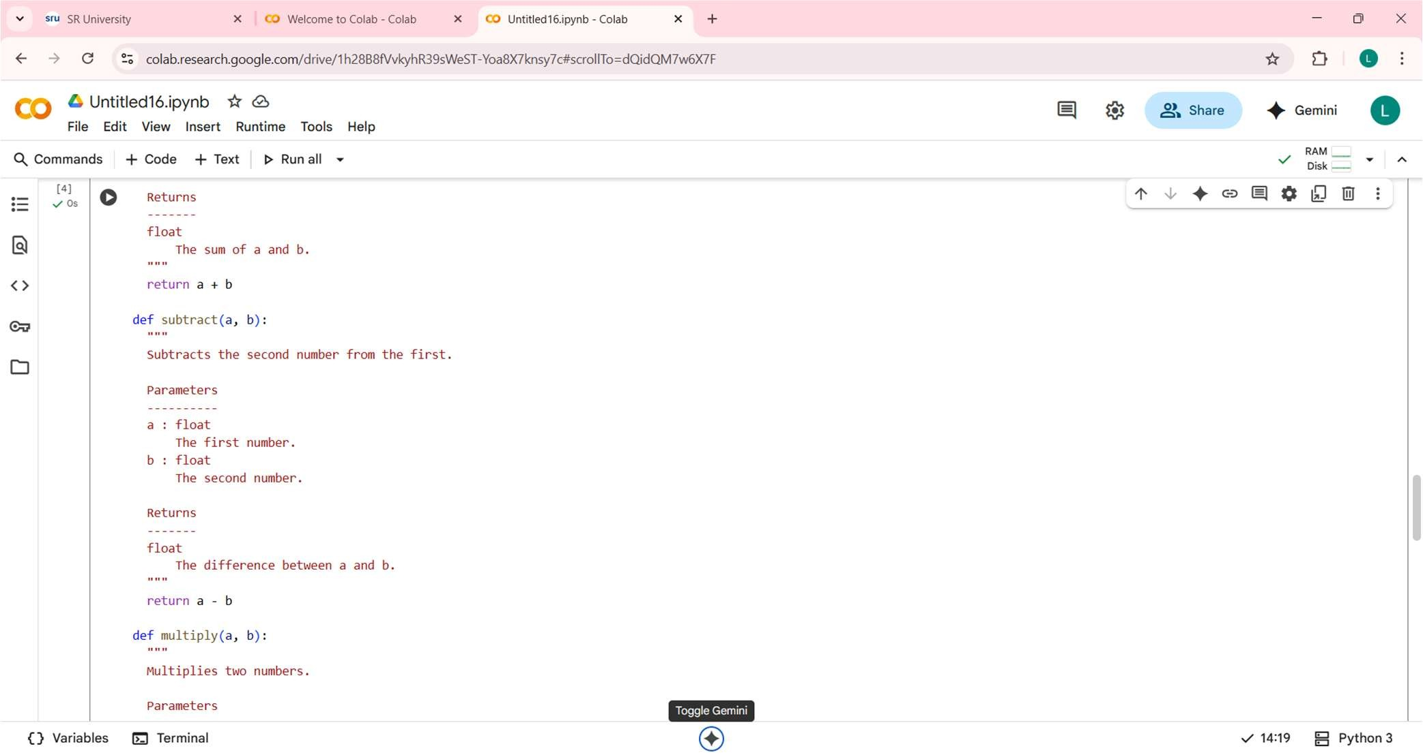

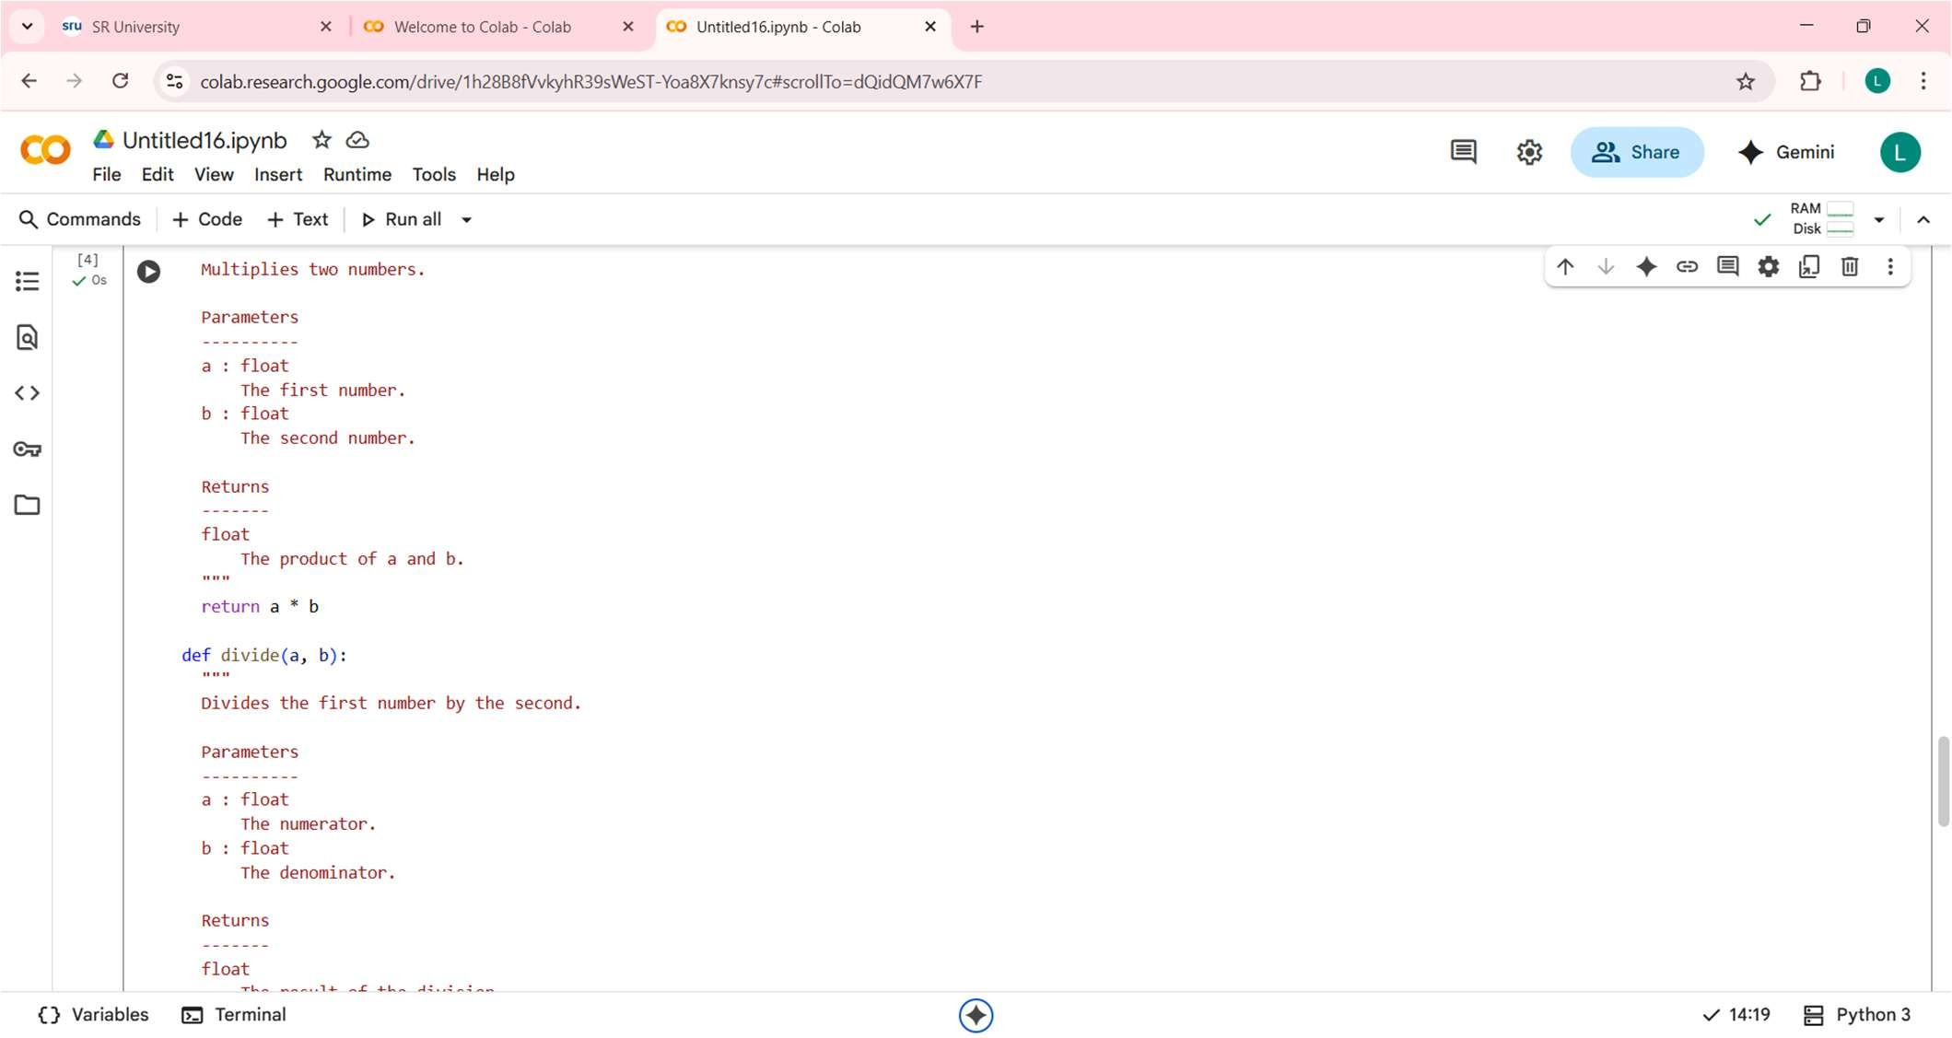

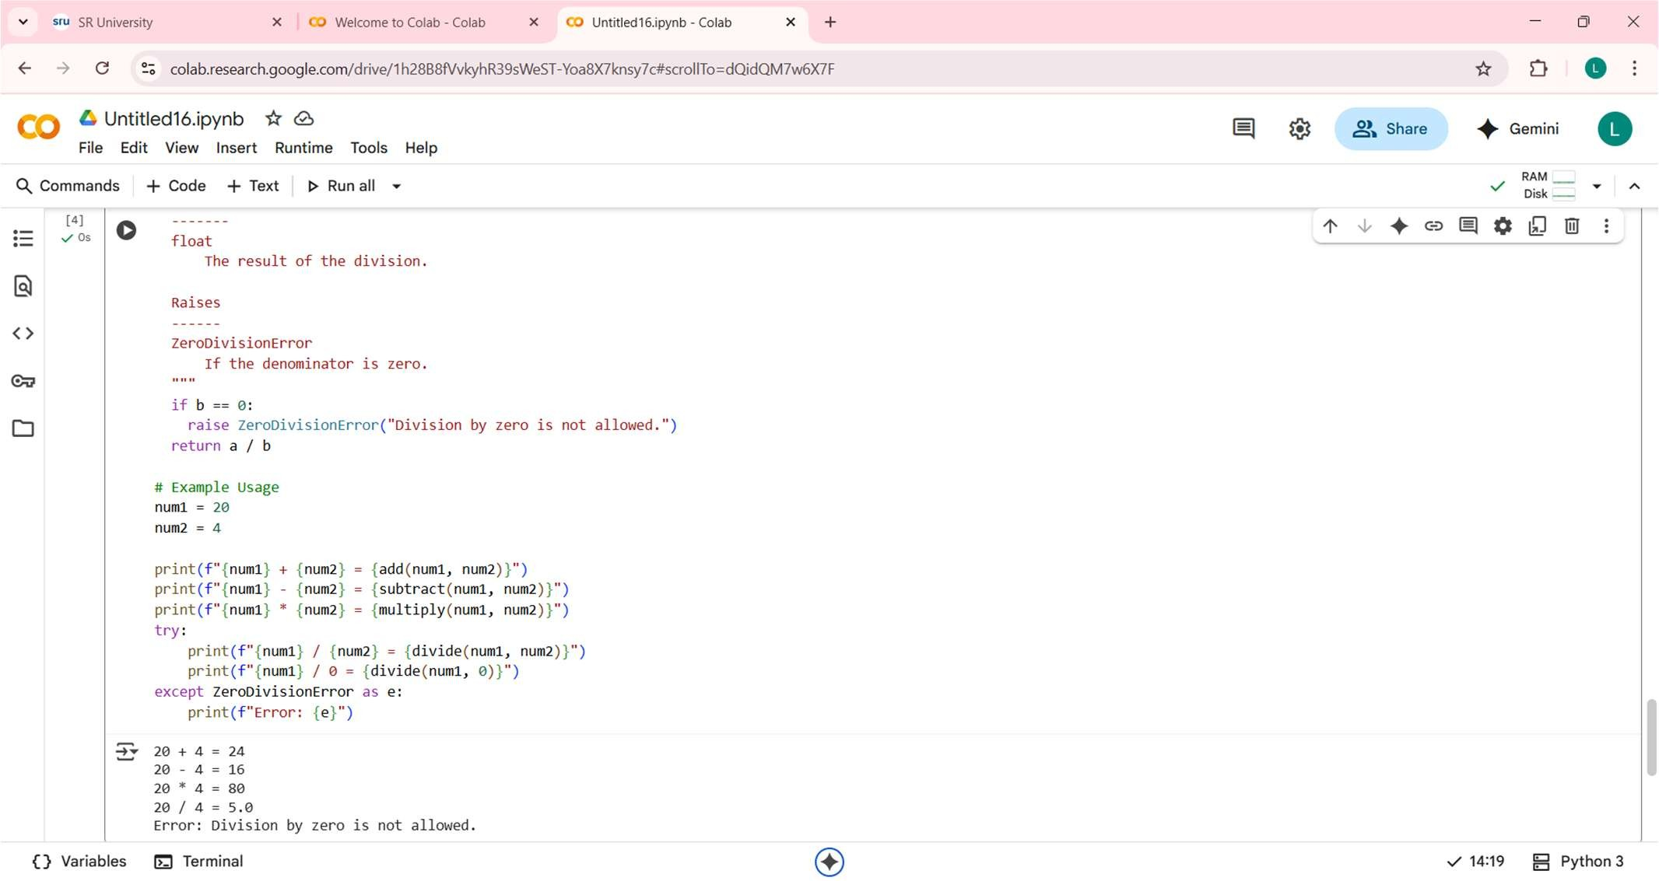

OUTPUT:
20 + 4 = 24
20 - 4 = 16
20 * 4 = 80
20 / 4 = 5.0
Error: Division by zero is not allowed.
OBSERVATION:
The code defines a simple calculator module with add, subtract, multiply, and divide functions.
Each function includes clear NumPy-style docstrings explaining its purpose, parameters, and return value.
The divide function correctly handles division by zero by raising a ZeroDivisionError.
The example usage demonstrates calling each function with specific numbers.
The output shows the results of the arithmetic operations.
It also shows the ZeroDivisionError being caught and printed when attempting division by zero.
This confirms the functions work as expected and error handling is in place.
The code is well-documented and easy to understand due to the docstrings.
It's a good example of defining reusable functions and handling potential errors.

